Subject: MBA 915 – Leading Business Transformation in the Age of AI

Assignment: No 3 – Project Retrospective Report

Organisation: Green Connect Farm

Due Date: 20/4/25

Submission Date: 20/4/25

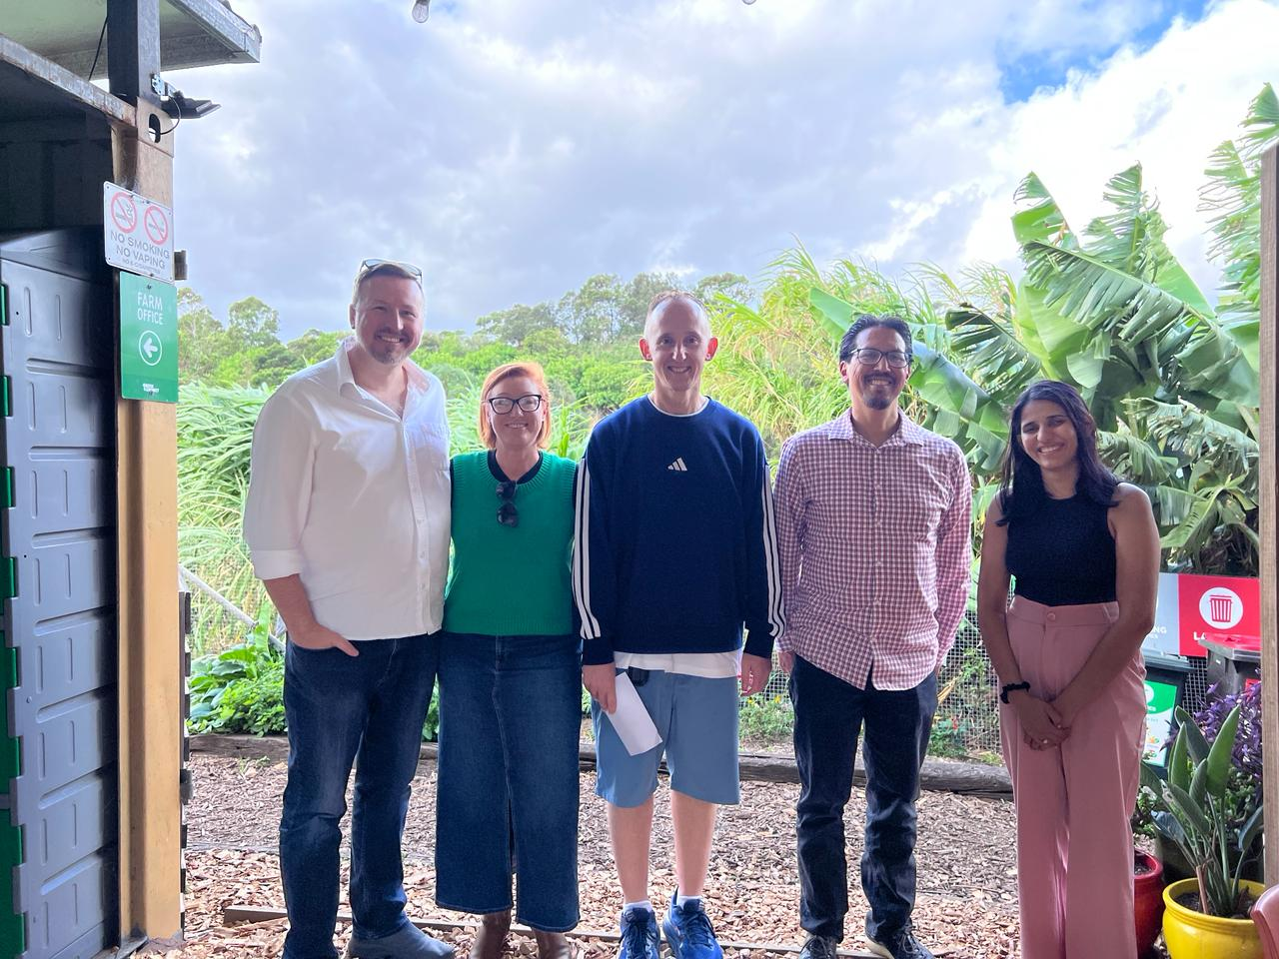

Executive Summary
Embracing an enviable mission to promote sustainability, fair food production, and social inclusion, Green Connect intricately balances the importance of caring for both people and the planet. Articulating our vision, this report reports on five key deliverables. Among them is the application of Artificial Intelligence AI and its potential to streamline administrative processes. Presented creatively, our report also explores how innovation can enhance operational efficiency and community impact for Green Connect.
Project Purpose & Alignment with Learning Outcomes
Our project was driven by a vision to harness digital innovation to support a purpose-driven organisation, Green Connect. Committed to sustainability, ethical food systems, and social inclusion, Green Connect has created 177 employment opportunities, diverted 143 tonnes of waste from landfill, and distributed over 36,000 kg of produce in 2024 alone. This aligned perfectly with our desire to apply AI-enabled business transformation in a real-world setting (LO3, LO4).
Following Green Connect’s organisational refocus on Fair Food and Farm programs in March 2025, our team collaborated with CEO, Robert Servine to identify practical and scalable improvements(Servine, 2025). What began as a focus on work readiness delivery shifted towards more immediate operational needs. This resulted in two key AI interventions: the automation of veg box administration to scale output to 220 boxes/week and streamlining back-end administrative tasks. These digital strategies directly reflect learning outcomes (LO3 and LO4) by applying digital transformation models to support business sustainability and growth.
We applied the ADKAR model(Hiatt, 2006), to guide our implementation process:
Awareness – Identifying the strategic need for digital transformation and scalability.
Desire – Shared team commitment to leveraging AI to achieve social enterprise goals.
Knowledge – Research into AI tools and platforms, supported by collaborative technologies.
Ability – Creation of a veg box automation system and a no-code chatbot prototype.
Reinforcement – Stakeholder feedback loops ensure continued improvement and system longevity.
Our project embodied multiple course concepts: we developed a digital blueprint (LO3), evaluated AI adoption strategies (LO4), ensured alignment with ethical and governance considerations (LO5), and used AI tools to derive insights for real-world recommendations (LO6).
Through multiple engagements with the CEO and on-site observations, we validated our approach against Green Connect’s mission and operational context.
The project outcomes enhanced scalability, leadership capability, customer experience, operational efficiency, and long-term impact. Subsequently, the team demonstrated the tangible value of digital transformation in the not-for-profit sector.
Innovation & Creative Process
Our group adopted a dynamic and exploratory approach that aligned with Green Connect’s mission of sustainability and social enterprise. Importantly, the team elected to embrace ‘storytelling’ as our preferred methodology to convey the application of Artificial Intelligence AI. The integration of photos, videos, and other visual materials facilitated the opportunity to bring our audience on an interactive journey.
This approach not only deviated from traditional report formats but also reflects an increasing trend in digital communication that emphasises user interactivity and visual engagement (Fuchs, 2021 ). Furthermore, the use of AI tools in content generation is gaining momentum in both academia and industry, with research suggesting that such technologies can enhance creative processes and knowledge dissemination(Dwivedi, 2023).
Throughout the development phase, we experimented with numerous tools and layouts, iteratively refining our design based on peer feedback and usability testing. Specifically, some of these tools encompassed: Gamma.ai, ChatGPT, Google Gemini, Virtual & Augmented Reality, Monday.com, and Zappia. Furthermore, interviewing the CEO enabled the team to qualify the appropriateness of potential solutions(Servine, 2025). Throughout the interview, it also emerged how there was an important requirement to address the issue that currently, phone calls initiated by potential customers are diverted to different people and places. That is, Green Connect does not have a consistent process. Consequently, prospective customers may be overlooked(Servine, 2025).
By embedding innovation into both our methodology and final output, we not only captured the spirit of Green Connect’s values but also demonstrated adaptability to evolving communication and digital technologies.
Execution & Real-World Applicability
As part of our project with Green Connect, our team designed and delivered a multimedia prototype: a dynamic, interactive website created using Gamma.ai. This digital solution authentically reflects Green Connect’s mission of sustainability and social inclusion by showcasing curated photos, video content, and a recorded interview with the organisation’s CEO.
Enhancing real-world usability, the website also integrates the use of a chatbot. The chatbot will serve as a first point of contact for visitors, capable of answering common questions related to Green Connect’s produce boxes, farm tours, volunteer opportunities, and educational programs. Research highlights that chatbots significantly improve user engagement and customer satisfaction by offering immediate, 24/7 support (Chaves and Gerosa, 2020). Incorporating the use of a ‘no-code’ chatbot builder, this aligns with literature supporting the accessibility of AI-driven interfaces for resource-constrained organisations (Maedche et al., 2019).
The successful implementation of this AI-driven solution is guided by the ADKAR model of change management—Awareness, Desire, Knowledge, Ability, and Reinforcement (Hiatt, 2006). For example, building awareness among staff and volunteers about the benefits of chatbot integration is critical. Creating desire involves highlighting how the chatbot can reduce manual admin while enhancing public interaction. Providing knowledge and ability through training and support materials ensures that team members can manage and update chatbot content confidently. Finally, reinforcement will be essential. This will be accomplished via the provision of user feedback and performance analytics—to continuously improve and sustain the system's effectiveness.
Our prototype is highly feasible in a real-world setting. It leverages AI-supported tools to create an engaging user experience that is both cost-effective and scalable—critical considerations for a not-for-profit.
Moreover, industry insights indicate that more than 60% of consumers now prefer interacting with chatbots when seeking quick responses to simple queries(SalesForce, 2022), supporting our decision to embed conversational AI.
However, we encountered a few constraints. The Gamma.ai platform offered limited design flexibility, and time constraints impacted our ability to refine content across iterations. Ensuring compliance with data privacy and obtaining informed consent during interviews also required careful planning. Additionally, chatbot scripting must be continuously reviewed to ensure tone and content align with Green Connect’s values.
Overall, the project demonstrated the practical potential of AI to enhance service delivery, storytelling, and customer experience in the not-for-profit sector.
Collaboration & Team Dynamics
Team collaboration evolved naturally. Marc and Melinda first connected in class, with Shivani later reaching out and involving Yul. This ‘Forming’ stage was inclusive and efficient.
The ‘Storming’ phase included challenges—schedule clashes, rapid messaging, and uncertainty around the project scope. Nevertheless, the group remained committed and responsive.
Once we agreed upon the scope of work, each member`s role emerged organically:
- Melinda led stakeholder engagement.
- Marc managed project direction and progress.
- Yul contributed AI platform and marketing knowledge &
- Shivani offered prior AI experience and insights.
As the project matured into the ‘Performing’ phase, the team`s motivation increased. A positive, encouraging environment enabled members to contribute confidently—characteristics of high-functioning, psychologically safe teams(Edmondson, 1999).
After meeting Green Connect’s CEO on 5 April 2025 (Servine, 2025), the team pivoted to more relevant options without resistance—an agile response aligned with dynamic team learning(Sundstrom et al., 1990).
The team communicated via ‘WhatsApp’, supporting timely collaboration amid varying schedules.
To manage deliverables:
- Marc and Melinda prepared the retrospective report.
- Yul and Shivani developed the digital platform &
- All members attended meetings for shared learning and cohesive execution.
Communication & Delivery Strategy
Our team adopted an open and collaborative communication style, ensuring everyone`s opinion was heard and valued throughout the decision-making process. Collectively, the team agreed to focus our presentation and final artefact on Green Connect’s core values—sustainability, community inclusion, and ethical food production. These themes guided the selection of content, ensuring alignment with stakeholder expectations and the organisation’s mission.
To convey impact and insight, the team unanimously agreed on the importance of visiting the farm in person. This provided an invaluable opportunity to meet and discuss how the application of AI could contribute value. The team used Gamma.ai to design an interactive website featuring curated images, videos, and a recorded interview with the CEO. This multimedia approach highlighted the human stories behind the enterprise and brought authenticity to our prototype.
To enhance usability, we proposed the integration of a no-code AI chatbot to assist with customer enquiries. This tool is supported by literature promoting AI accessibility for resource-limited organisations(Maedche et al., 2019), and improves user engagement(Chaves and Gerosa, 2020). Furthermore, in the absence of coding expertise, our team leveraged the use of GenAI platforms encompassing ChatGPT to identify and assist with the process of designing our chatbot(OpenAI, 2025).
Our artefact is both accessible and engaging, designed with intuitive navigation and mobile responsiveness. The combination of multimedia and AI integration ensures broad appeal across different user demographics and learning preferences, offering a compelling, real-world solution.

Critical Reflection & Lessons Learned
What Worked Well
Team collaboration was rooted in mutual respect and diverse strengths. Members contributed expertise in stakeholder engagement, technology, and values alignment, enriching the project’s depth. Flexibility around availability fostered supportive, adaptive working relationships.
From the outset, bonds formed and strengthened, particularly during personal challenges. This professionalism and shared commitment enabled high-functioning teamwork.
The project aligned closely with Assessment 2, generating productive discussions. Green Connect’s CEO, Robert Servine, and his team showed strong engagement, enhancing our approach with their openness and enthusiasm.
Challenges Encountered
Time constraints, fluctuating availability, and delivery pressure created some anxiety, managed through communication, role clarity, and support.
Key Lessons Learned
- AI Transformation:
AI proved adaptable, enabling creative, actionable solutions. A key insight was the importance of exploring and integrating multiple platforms.

- Leadership:
Robert Servine exemplified purpose-driven leadership, blending strategic planning with emotional intelligence. His inclusive approach empowered staff and drove innovation.

- Team Dynamics:
The group reflected a senior leadership team—leveraging complementary skills, forming friendships, and resolving issues through open, professional dialogue.

- Teamwork:
Empathy and psychological safety were crucial. Mutual encouragement helped manage pressure and ensure a rewarding experience.

Opportunities for Improvement
Greater focus and division of tasks would improve AI administration components. To enhance veg box logistics, deeper system access and time investment are required for seamless integration with current processes.

List of References
CHAVES, A. P. & GEROSA, M. A. 2020. How should my chatbot interact? A survey on human–chatbot interaction design. nternational Journal of Human–Computer Interaction, 36, 526–544.
DWIVEDI, Y. K., HUGHES, D. L., BAABDULLAH, A. M., ET AL 2023. Artificial Intelligence (AI): Multidisciplinary perspectives on emerging challenges, opportunities, and agenda for research, practice and policy. International Journal of Information Management. , 71.
EDMONDSON, A. 1999. Psychological Safety and Learning Behavior in Work Teams. Administrative Science Quarterly, 44, 350-383.
FUCHS, C. 2021 Social media: A critical introduction (3rd ed.) SAGE Publications.
HIATT, J. 2006. ADKAR: A model for change in business, government and our community. , Loveland, CO: Prosci Research.
MAEDCHE, A., LEGNER, C., BENLIAN, A., BERGER, B., GIMPEL, H., HESS, T., HINZ, O., MORANA, S. & SÖLLNER, M. 2019. AI-based digital assistants. Business & Information Systems Engineering, 61, 535–544.
OPENAI 2025. ChatGPT 40.
SALESFORCE. 2022. State of the Connected Customer [Online]. Available: https://www.salesforce.com/resources/research-reports/state-of-the-connected-customer/ [Accessed 17/4/25 2025].
SERVINE, R. 15/4/25 2025. RE: Interview with CEO.
SUNDSTROM, E., DE MEUSE, K. P. & FUTRELL, D. 1990. Work teams: Applications and effectiveness. American psychologist, 45, 120.

